**English**

* Spell words containing each of the 40+ phonemes already taught
* Begin to form lower-case letters in the correct direction, starting and finishing in the right place
* Say out loud what they are going to write about
* To form capital letters.

**List, noun phrase, simple sentence** 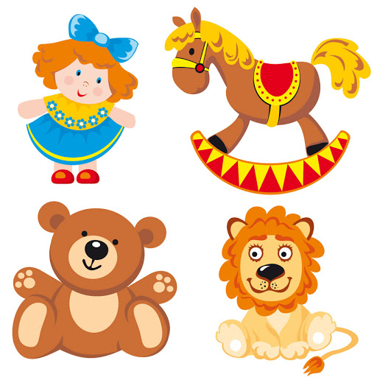

**List, noun phrase, simple sentence**

**Mathematics**

* Count to and across 100, forwards and backwards, beginning with 0 or 1, or from any given number
* given a number, identify one more and one less
* identify and represent numbers using objects and
* pictorial representations including the number line, and use the language of: equal to, more than, less than (fewer), most, least
* read and write numbers from 1 to 20 in numerals and words

**ICT**

To recognise common uses of information technology in the home and school environment.

**Digital citizenship**



**PSHE/P4C**

Learning about our school value of respect.

Identifying emotions and what makes a good friendship.

**Music**

* play tuned and un-tuned instruments musically.

**Percussion instruments**

**History**

* To ask questions about the past.
* Describe some simple similarities and differences between artefacts.
* Sequence events and recount changes within living memories.
* Talk, draw and write about aspects of the past.
* Identify similarities and differences between different periods in life.

**Study of old toys**

**Art/ DT**

**•** use artwork to record ideas, observations and experiences

• explain what he/she likes about the work of others

• use a variety of tools including pencils, rubbers, crayons, pastels, felt tips, charcoal, ballpoints, chalk and other dry media to represent objects in lines.

• explore mark-making using a variety of tools

• make marks in print using found objects and basic tools and use these to create repeating patterns

**Teddy sketch, building marble run**

Autumn 1

This half term **Year 1’s topic is:**

**Toys**

**Science**

* Distinguish between an object and the material from which it is made
* Identify and name a variety of everyday materials, including wood, plastic, glass, metal, water, and rock
* Describe the simple physical properties of a variety of everyday materials
* Compare and group together a variety of everyday materials on the basis of their simple physical properties

**Materials**

**RE**

* Communicate
* Apply
* Enquire
* Contextualise  
  Evaluate

**Celebrating harvest**