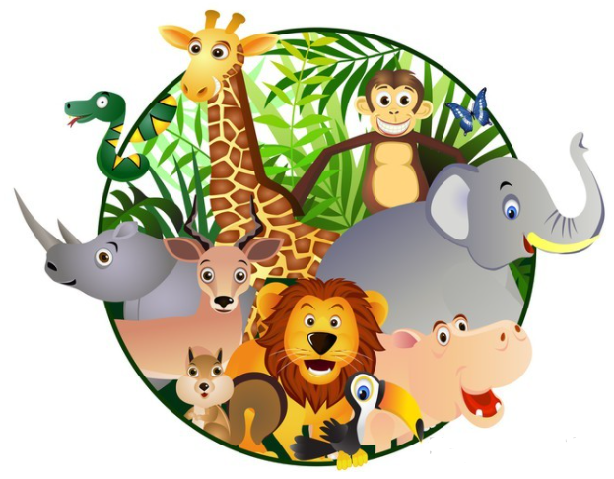
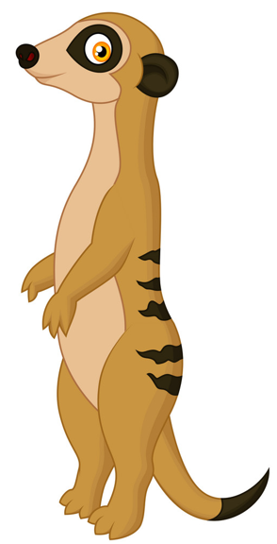
On Safari
Autumn 1 2021
Year 2
Geography: On Safari
Geographical Skills and fieldwork:
- Ask simple geographical questions.
RE: Why did people do what Jesus asked them?
Concept: Persuasion
- Describe in simple terms what persuades them.
- Simply describe how persuasion works in their life, and how others may be persuaded differently.
- Simply describe how persuasion is effective in everyday life.
- Describe simply how/why people were persuaded to follow Jesus.
- Describe simply why people might not have been persuaded to follow Jesus.
PE:
Monday (pm) Gymnastics Tuesday (am) Games
Gymnastics:
- Isolated parts of the body using floor and hold balance.
- Develop range of gymnastic moves particularly balance.
- Create short sequences using gymnastic actions to no music.
- Explore ways of travelling around on large apparatus.
Ball Skills:
- Catching, throwing variety of objects/balls.
- Kick and move with a ball.
- Retrieve and stop a ball using different parts of the body.
- Start to look at moving with a ball.

Computing: Computers and using computers:
- Recognise common uses of information technology beyond school.
- Use technology to purposely create, organise, store, manipulate and retrieve digital content.
Music: Dragons
Dimensions Focus: dynamics & tempo
- Dynamics: Respond to, recognise and identify getting louder and quieter.
- Tempo: Respond to, recognise and identify getting faster and slower.

Skills:
- Singing: Explore and use vocal tones, chant and sing a wider variety of rhymes and songs with an awareness of character and/ or mood. Use simple vocal patterns as accompaniments.
- Playing: Demonstrate accuracy and control of correct technique on a range of untuned percussion instruments. Begin to play with musical intent.
- Rehearsing and performing: Sing and play in time and follow a wider range of simple directions, develop awareness of why and how to improve.
- Notating: Respond to, identify and use symbols and other graphic notation illustrating the musical dimensions.
- Listening and responding: Respond to, identify, and distinguish between sounds and music in different contexts.
- Begin to consider how music illustrates the composer’s ideas.
Value: Respect
Art:
Drawing:
- Try out different activities and make sensible choices about what to do next.
- Represent things observed, remembered or imagined using colour.
Painting:
- Select particular techniques to create a chosen product and develop some care and control over materials and their use.
- Represent things observed, remembered or imagined using colour/ tools.
Printing:
- Use a variety of techniques including carbon printing, relief, press and fabric printing and rubbings.
- Know that different artistic works are made by craftspeople from different cultures and times.

Science: Animals including humans
- Notice that animals, including humans, have offspring which grow into adults.
- Find out about and describe the basic needs of animals, including humans, for survival (water, food and air).
- Describe the importance for humans of exercise, eating the right amounts of different types of food, and hygiene.
Design Technology:
Cooking:
- Understand the need for a variety of food in a diet.
- Group familiar food groups e.g. fruit and vegetables.
- Measure and weigh food items – using informal methods.
Where do meerkats live?

