**Reading**

* A book is made of pages that have words and pictures
* A book is read from left to right
* Stories have a beginning, a middle and an end.
* There are lots of different books: stories, fairy tales, traditional tales.
* I can recognise and read my name
* I can say the sounds of the letters S, A, T , P, I , N.

**Maths**

* I know Numbers are what we use for counting and measuring.
* I recognise the numbers 0 1 2 3 4 5 6 7 8 9
* I can count each item one at a time
* I can count to 5
* I know how many items to get to show 1, 2, 3, 4, 5.

**Physical development:**

* I can move safely in different spaces
* I can move in different ways
* I can be safe when taking risks e.g. jumping or moving a crate
* I can hold my pencil in my writing hand
* I can hold simple tools e.g. scissors safely and correctly



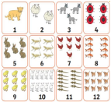

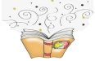

**Giraffe’s Curriculum News**

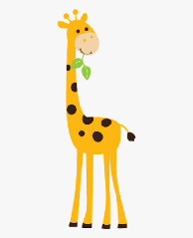

**Phonics:**

Phonics is a way of learning to read, by understanding the sounds that letters make.

* I know the 26 letters in the alphabet: A B C D E F G H I J K L M N O P Q R S T U V W X Y Z Letters can be either vowels (A, E, I, O and U) or consonants (all of the other letters)
* I can say the sounds of the letters S, A, T, P, I N
* I can start to blend and say/read some simple words, s-i-t, p-i-n.

**Understanding the world**

* I can explore the world around me
* I can make observations and draw pictures of animals or plants

**Autumn 1**

**2021**

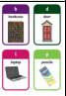

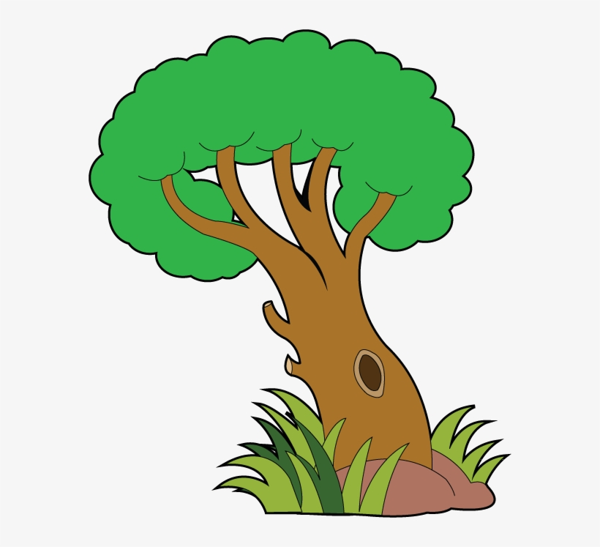

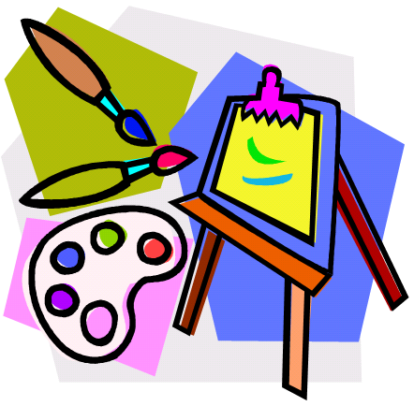

**Our Topic is: All About Me**

**Expressive Art and Design**

* I can safely use a range of tools: scissors, paint brushes, glue sticks
* I can share with an adult what I have created
* I can create my own stories/role play

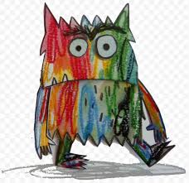

**Personal, social, emotional development:**

**Respect**

* I know how to show respect
* I can follow school rules
* I can take turns and share
* I can be safe
* I can tell an adult how I’m feeling
* I know the emotions- happy, sad, angry, worried.

**Literacy**

* Know that marks have meaning
* Know that symbols and letters communicate a meaning
* Know that there are small letters and large letters
* Know that some letters are taller and that some go below the line.

Writing outcomes:

* Mark making
* Spelling and writing my name
* List writing

**Communication & Language:**

* I can speak to different adults in a pleasant voice
* I can listen and respond to an instruction or question
* I can re-tell a simple story

