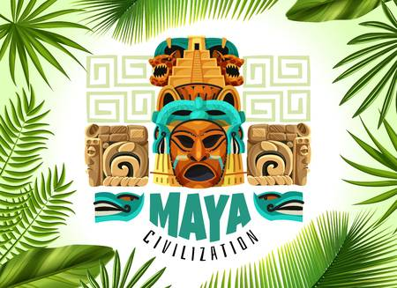

History – Maya Civilisation

* To ask questions and make predictions about the past
* To make confident use of a variety of sources for independent research
* To understand how our knowledge of the past is constructed from a range of sources#
* To construct informed responses that involve thoughtful selection and organisation of relevant historical information
* To address and sometimes devise historically valid questions about change, cause, similarity and difference, and significance
* To describe a non-European society (Maya) that provides contrasts with British history
* To describe a chronologically secure knowledge and understanding of British, local and world history.

Year 6 - Otters Autumn Term 1

Maya Civilisation

Trips

TBC

Computing – E-Safety

* To use technology respectfully and responsibly identify a range of ways to report concerns about content and contact in and out of school

PE

Netball

Spanish – Greetings

* To understand an increasing amount of familiar spoken phrases.
* To answer simple questions and give basic information.
* To identify similarities between my culture to that of another
* To learn and talk about celebrations in other cultures and know about daily life in other countries that are different to my own.
* To write one or two short sentences with support

Art – Mayan Masks, Murals & Weaving

* To begin to develop an awareness of composition, scale and proportion in their work
* To use techniques, colours, tones and effects in an appropriate way to represent things seen - brushstrokes following the direction of the grass, stippling to paint sand, watercolour bleeds to show clouds
* To produce intricate patterns and textures in a malleable media

Music

Composition throughout History

PSHE

School Value - Respect

Science – Light

* To recognise that light appears to travel in straight lines
* To use the idea that light travels in straight lines to explain that objects are seen because they give out or reflect light into the eye
* To explain that we see things because light travels from light sources to our eyes or from light sources to objects and then to our eyes
* To use the idea that light travels in straight lines to explain why shadows have the same shape as the objects that cast them

Geography – Central America

* To use maps, atlases, globes and digital/computer mapping to locate countries and describe features studied
* To locate the world's countries, using maps to focus on South America, concentrating on their environmental regions, key physical and human characteristics, countries, and major cities
* To describe and understand key aspects of physical geography

RE - Laws

* To explain what people mean by laws and how they compare with rights and rules.
* To explain how Jesus’ attitude to the Law is significant within the Easter story.
* To evaluate, by explaining, the value of Jesus’ attitude to laws and wider issues about laws
* To explain a personal response to the concept of laws and law-breaking
* To explain the concept of laws to their own and others’ lives