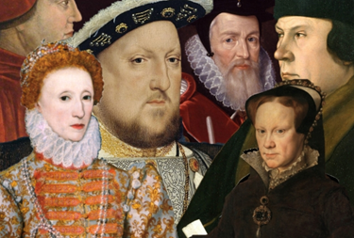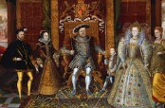

**History – The Tudors**

• Use dates to order and place events on a timeline

• Understand that the type of information available depends on the period of time studied.

• Evaluate usefulness of a variety of sources.

• Make comparisons between aspects of periods of history and the present day.

• Present findings and communicate knowledge and understanding in a variety of ways.

• Give some reasons for important historical events

• Compare sources of information available for the study of different times in the past.



**Art – Tudor Portraits**

• To learn new techniques and apply them in context.

• Use sketchbooks to record observations

• improve their mastery of art and design techniques, including drawing

**Trips –**

**Tudor House - TBC**

**PSHE/RSE**

* Respect/Challenging Relationships/Rule of Law

**MFL – Spanish**

* To be able to understand that there are people and places in the world around me that are different to where I live and play.
* To be able to understand that some people speak a different language to my own.
* To be able to say and repeat a few short words or phrases.
* To write and copy simple phrases. To be able to understand a few familiar spoken words and phrases.

**PE –**

**Mondays 13:15 – 14:00** Netball (coach)

**Thurs 2:10- 2:50** Fitness

* Fitness - Understanding the importance of warming up properly
* Learning fitness skills during circuit training
* Measuring effects of exercise on pulse rate
* Design a fitness circuit that has stations that has exercises that affect different parts of the body.

**RE –**

* Belonging (in Islam)
* Begin to explain their response to the concept of belonging.
* Begin to explain what it means to belong to something.
* Begin to explain how belonging is important to Muslims.
* Evaluate, by describing in simple terms, the importance to believers and to themselves of belonging.

**Tudors**

**Autumn 1– Year 5**

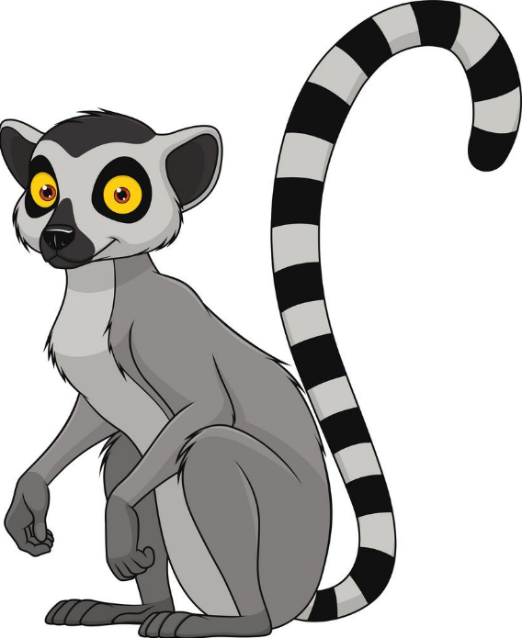

**ICT**

* Understand computer networks, including the internet.
* Use technology safely.
* Use of PowerPoint

**Science – Properties of Materials**

* Compare and group together everyday materials on the basis of their properties, including their hardness, transparency, and conductivity (electrical and thermal)
* Give reasons, based on evidence from comparative and fair tests, for the particular uses of everyday materials, including metals, wood and plastic
* Planning different types of scientific enquiries to answer questions, including recognising and controlling variables where necessary
* Recording data and results of increasing complexity using tables and scatter graphs