 | Autumn 1 | Autumn 2 | Spring 1 | Spring 2 | Summer 1 | Summer 2
Year R  Link to characteristics of learning | Theme: Magnificent Me!  Skills:  Drawing – Pastel portraits  Painting – Autumn trees  Collage – Paper plate collage faces | Theme: Tell me a story Link to Julia Donaldson books  Skills:  Painting –character painting  Collage – character using a range of papers  Printing – printed cottage in woods using natural materials | Theme: Superheroes  Skills:  Drawing – Cartoon superheroes  Painting – design & paint own super heroes  Digital media – make a superhero using photos | Theme: Pirates & Mermaids  Skills:  Drawing – Under the sea picture  Painting – Paint a pirate ship  Collage: Decorate a mermaid tail  Sculpture – Create own pirate ship | Theme: Animals  Skills:  Drawing – shadow drawing  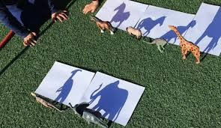  Printing – Printing sheep  Collage – paper plate hens  Textiles – Paper weaving animals | Theme: In the park link to Percy the Park Keeper  Skills:  Drawing – Design your own park  Painting – Paint a picture of one of the animals you might find in a park  Sculpture – Make a swing (use straws, wood & string)  ICT – Using paint program create a picture of the park
Year 1 | Theme: Toys  Skills: Drawing – observational drawing of a teddy bear  Painting – Andy Warhol style toy painting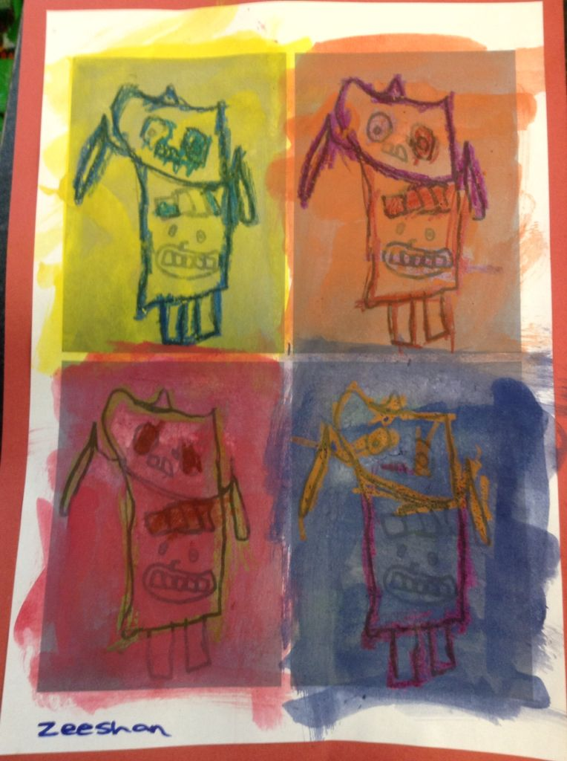  Printing – Lego printing  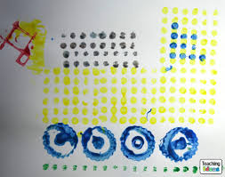 | Theme: Traditional tales  Skills: Drawing – Draw one of the characters  Painting – Paint a setting from the story  Collage: Using mixed media create a page for a story book with lever/slide | Theme: Dinosaurs  Skills:  Drawing – draw a dinosaur  Painting- create own dinosaur & include detail for scales using pattern  Printing – polystyrene fossil prints  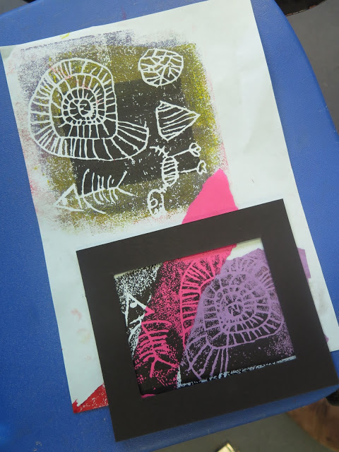 | Theme: Kings, Queens & Castles  Skills:  Drawing – Draw a picture of a king or queen  Painting – Make a painting of a King or Queen (mix colours)  Sculpture – Create a crown | Theme: Oceans & Seas  Skills: Drawing – wax resist under the sea pictures  Painting – Paint a picture of an underwater creature  Textiles – sewing fish using threads  Collage – Seaside scene using tissue paper background, sandpaper, sticky paper, foil. | Theme: Aliens & Monsters  Skills:  Drawing & Painting: Picasso monsters  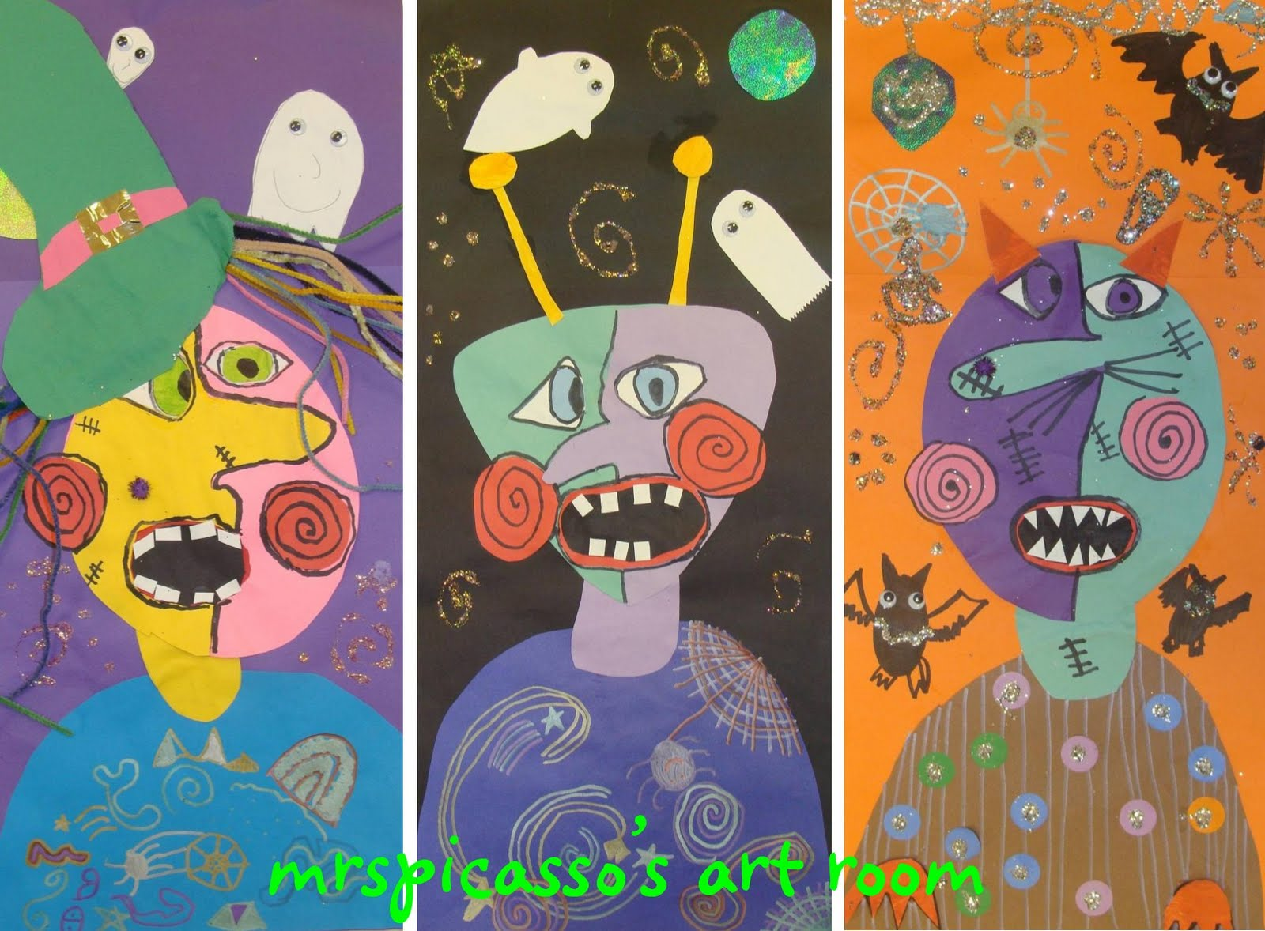  ICT: Create a picture of an alien or monster using paint on the computer. Try using a range of shapes.
Year 2 | Theme: On Safari  Skills: Drawing – draw repeating patterns  Painting – Paint animal prints  Printing – Create prints using a range of media e.g. cardboard, strings, potatoes | Theme: Great Fire of London  Skills: Drawing – Draw a scene of the great fire of London  Painting – Paint Blowing - fire pictures  Collage – Silhouette picture  ICT- Create pictures on paint of characters from Vlad | Theme: Fractured Fairy tales – 3 little pigs  Skills: Drawing – Draw houses for the little pigs  Painting/Printing – Create prints for the texture of house e.g. bricks, wood, straw  Sculpture – Clay model of character (pig or wolf) | Theme: Magic & potions (Roald Dahl – self-portraits)  Skills: Drawing – self-portraits using pencil  Painting – Picasso style  Sculpture – Abstract face using wire & pipe cleaners  Artist/ Craftsperson/ Designer: Quentin Blake, Picasso | Theme: Minibeasts  Skills:  Drawing – observational drawings  Painting – pebble painting  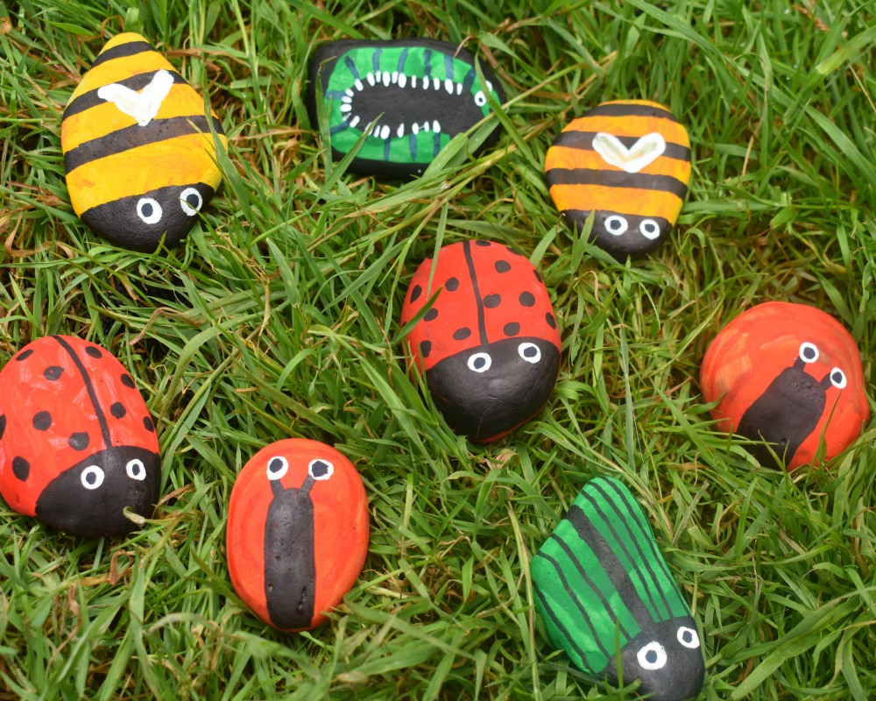  Textiles – paper weaving snail shells  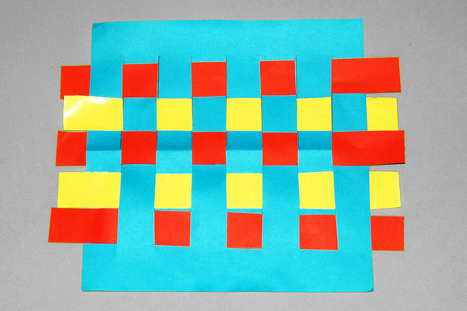 | Theme: Victorians  Skills:  Drawing – Victorian silhouette portraits  Painting – Victorian Prints  Printing – Create lino cut in the style of William Morris  Artist/ Craftsperson/ Designer: William Morris
Year 3 | Theme: Waterlooville  Skills:  Drawing – Local area landscape  Painting – Painting of playground in the style of Lowry  Collage – Landscape collage  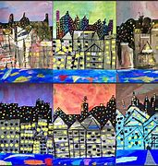  Artist/ Craftsperson/ Designer: L.S. Lowry – Playground Picture | Theme: Stone Age  Skills:  Drawing/ Painting: Cave paintings (use  charcoal sticks)  Textiles – Create an Iron age piece of clothing made by the whole class  Artist/ Craftsperson/ Designer: Look at historic art from that time | Theme: The UK  Skills:  Drawing – 3D map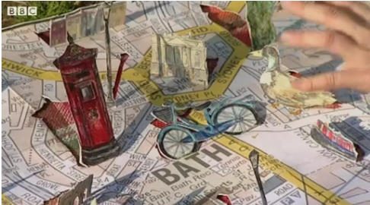  Drawing & painting: Pick a piece of Banksy work to recreate & adapt.  Printing – lino printing of iconic uk image e.g. crown, postbox etc  Artist/ Craftsperson/ Designer: Compare work of different UK artists  Banksy | Theme: Technology  Skills:  Drawing & painting – Own robot  Sculpture: Create a sculpture of your robot in the style of Collier  ICT: Use different forms of technology to create piece of work.  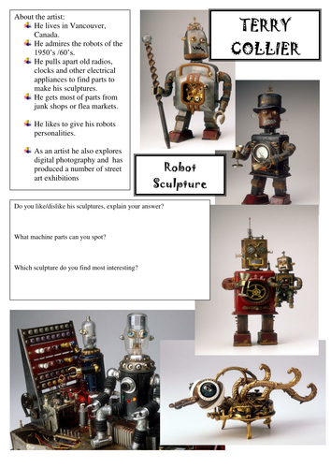  Artist/ Craftsperson/ Designer: Terry Collier | Theme: Romans  Skills:  Drawing – pen & ink roman numerals/names  Painting – Roman coin design  Collage – mosaics using paper tiles  Sculpture – Clay tiles, mark making relief patterns  Artist/ Craftsperson/ Designer: Look at historic art from that time | Theme: Zoo & animals  Skills: Drawing – Line drawings of animals from secondary sources  Wax resist poster for World Wildlife fund  Painting: In the style of Christopher Wood  Sculpture – Clay mini sculptures of animals (painted)  Artist/ Craftsperson/ Designer: Christopher Wood 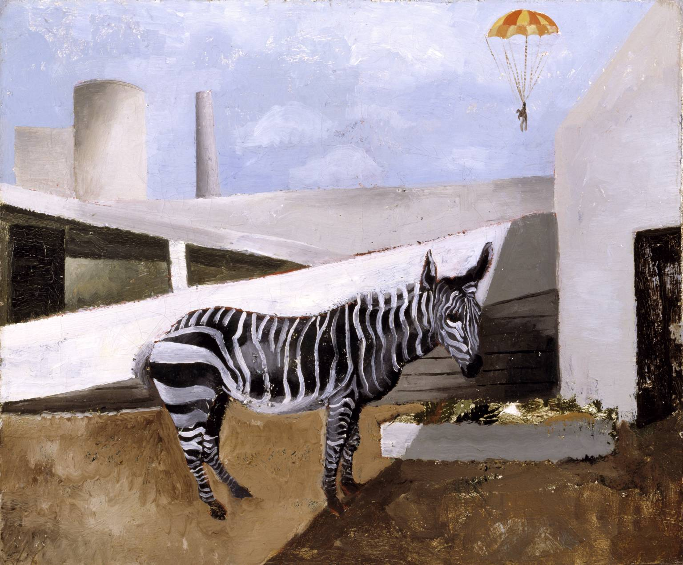
Year 4 | Theme: Titanic & the sea  Skills:  Drawing – Edwardian figures in lifeboats  Painting – Titanic posters style of retro posters/ watercolour paintings of The Titanic  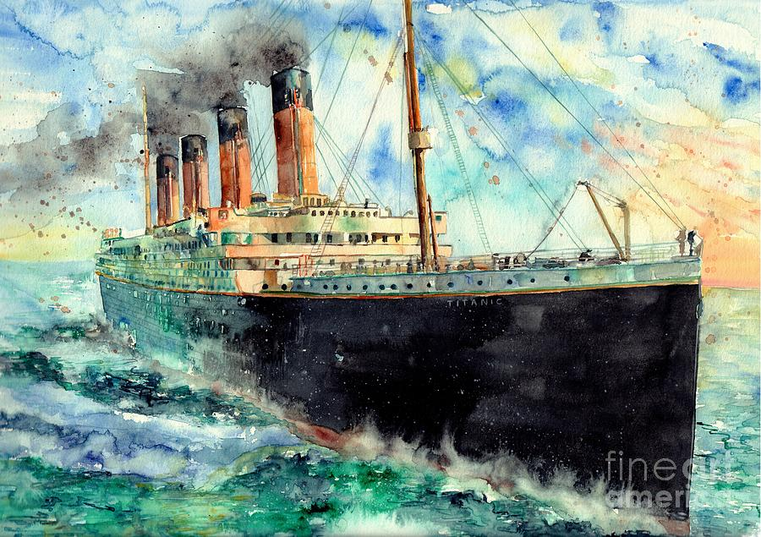  Printing – ships wheel designs used to make printing blocks.  Artist/ Craftsperson/ Designer: Study of Francis Davis Millet – died on the Titanic | Theme: Superheroes  Skills: Drawing – Draw own cartoon superhero  Painting – Design & paint own superhero emblem  Textiles & Printing – tie dye fabric to create a cape then print emblem  Artist/ Craftsperson/ Designer: Stan Lee | Theme: Rainforests  Skills:  Drawing – line drawings of animals  Painting – Colour matching, experimenting with different shades of green – painting in style of Rousseau  Collage – Mixed media (rainforest plants)  Artist/ Craftsperson/ Designer: Henri Rousseau | Theme: Myths (Beowulf)  Drawing: focus on drawing shapes and patterns  Painting: Experiment with colour and creating patterns  Printing: Print designs over a picture of face.  Artist: Kershaw & Topping ( Myth book)  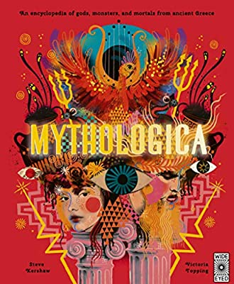Use as stimulus for drawing, painting & printing | Theme: Vikings  Skills:  Drawing – design Viking brooches  Painting/ Collage – Viking brooches using corrugated card, string, gemstones.  Sculpture – Clay Viking faces or long ships  Artist/ Craftsperson/ Designer: Paul Borda, Pinterest artist | Theme: Rivers, Coasts & Mountains  Skills:  Drawing – Using a pencil, sketch Mount Snowdon from different views whilst considering things in the foreground and background.  Painting – paint their own version of one on Monet’s River Thames paintings.  ICT & Collage: Collect images from the internet and create a mixed media collage of a coastline.  Artist/ Craftsperson/ Designer: Monet
Year 5 | Theme: Tudors  Skills:  Drawing – Tudor self-portraits in the style of Holbein  Painting – Choose a piece by Holbein to recreate  Printing – Tudor rose prints  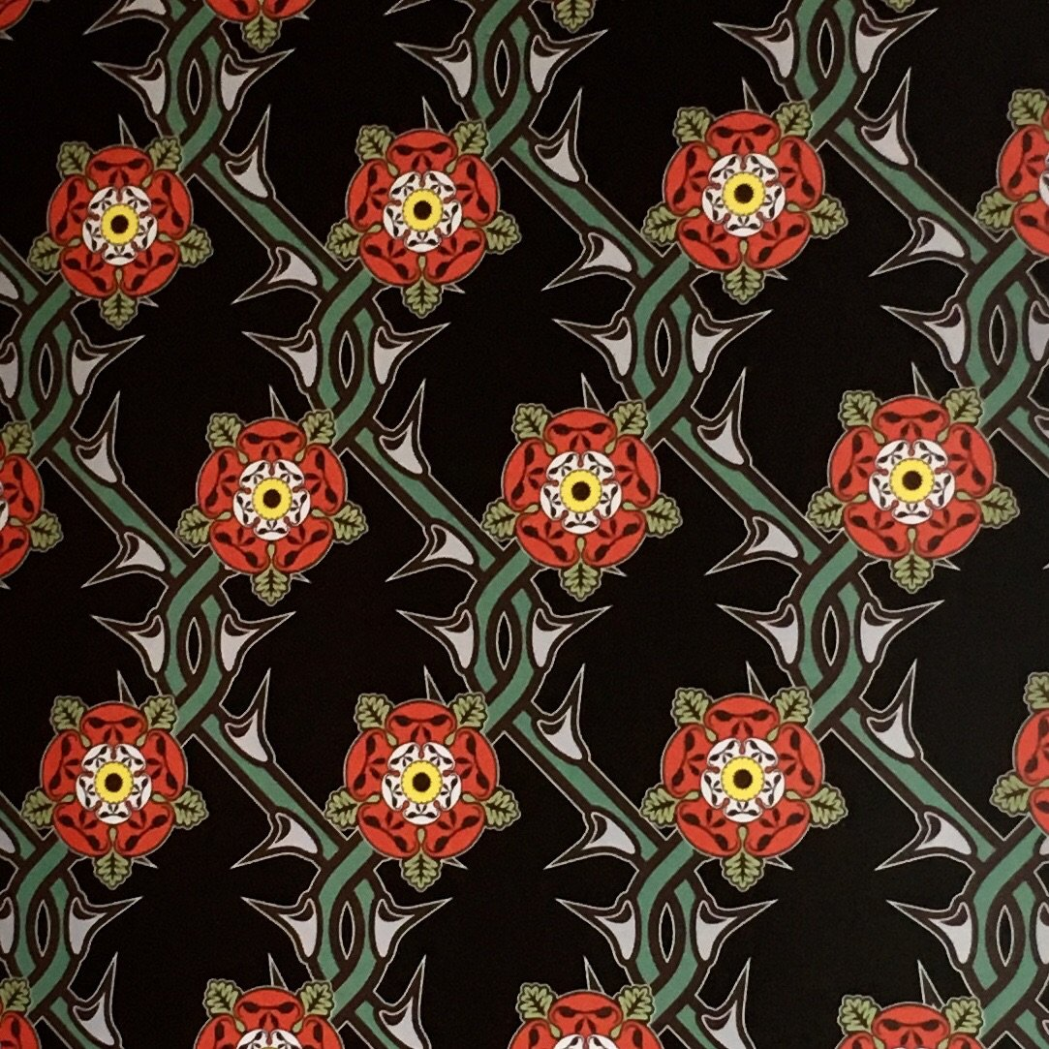  Artist/ Craftsperson/ Designer: Hans Holbein  https://www.hans-holbein.org/the-complete-works.html | Theme: Environment  Skills:  Drawing – Observations of plants & detail  Painting – Use of colour for plants  Collage – Natural objects collage  Artist/ Craftsperson/ Designer: Elizabeth Blackwell, Andy Goldsworthy | Theme: Space  Skills:  Drawing –  Texture space pictures using pastels  Painting – Peter Thorpe inspired rocket painting  ICT – Create a space background for rocket (photocopy rocket painting & stick onto background to create mixed media piece)  Artist/ Craftsperson/ Designer: Peter Thorpe | Theme: WW2  Skills:  Drawing – Sketch an example of Moore’s work  Painting - Create Blitz silhouette pictures 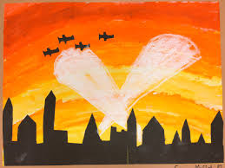  Digital media/Collage – create a WW2 propaganda poster (get images from the internet)  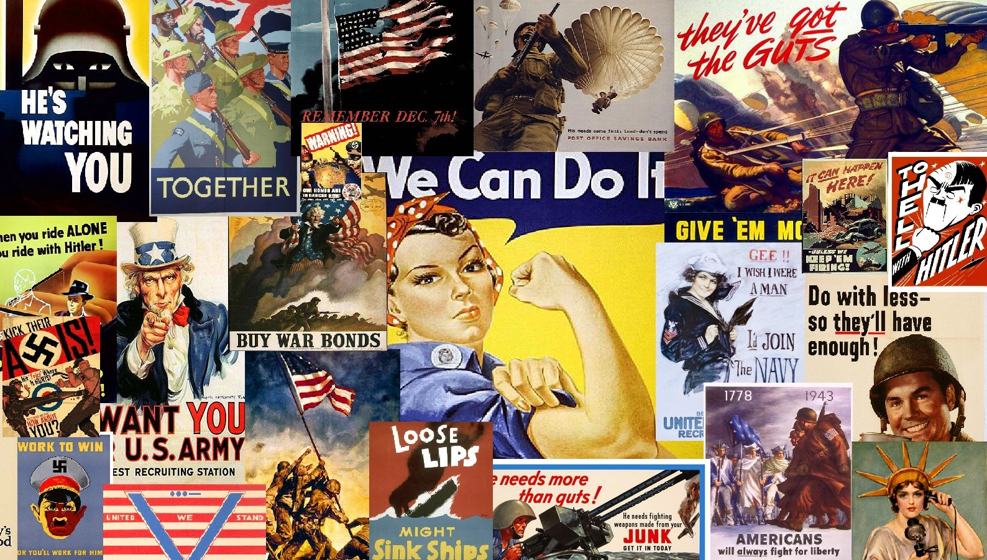  Artist/ Craftsperson/ Designer: Henry Moore | Theme: Fair Trade  Skills:  Drawing – Traditional African patterns  Painting – paint or block print African designs onto fabric  Textiles – tie dye fabric squares & add decoration. (Could stitch squares together to make a bag or cushion cover.  Artist/ Craftsperson/ Designer: Joseph Amedokpo | Theme: Ancient Egypt  Skills:  Drawing – Egyptian cartouche  Painting – Egyptian gods & hieroglyphs  Sculpture – Make mummies from twisted paper & modroc. Decorate with a sarcophagus  Artist/ Craftsperson/ Designer: Yliade (French Artist)  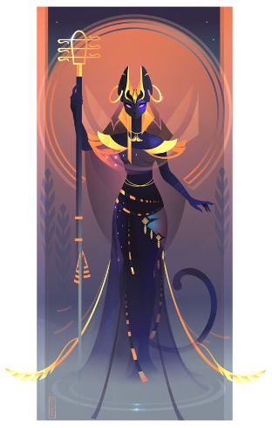
Year 6 | Theme: Mayans  Skills: Drawing - Create a Mayan mask  Painting – Mural paintings  Textiles – Mayan weaving  Artist/ Craftsperson/ Designer: Look at historic art from that time  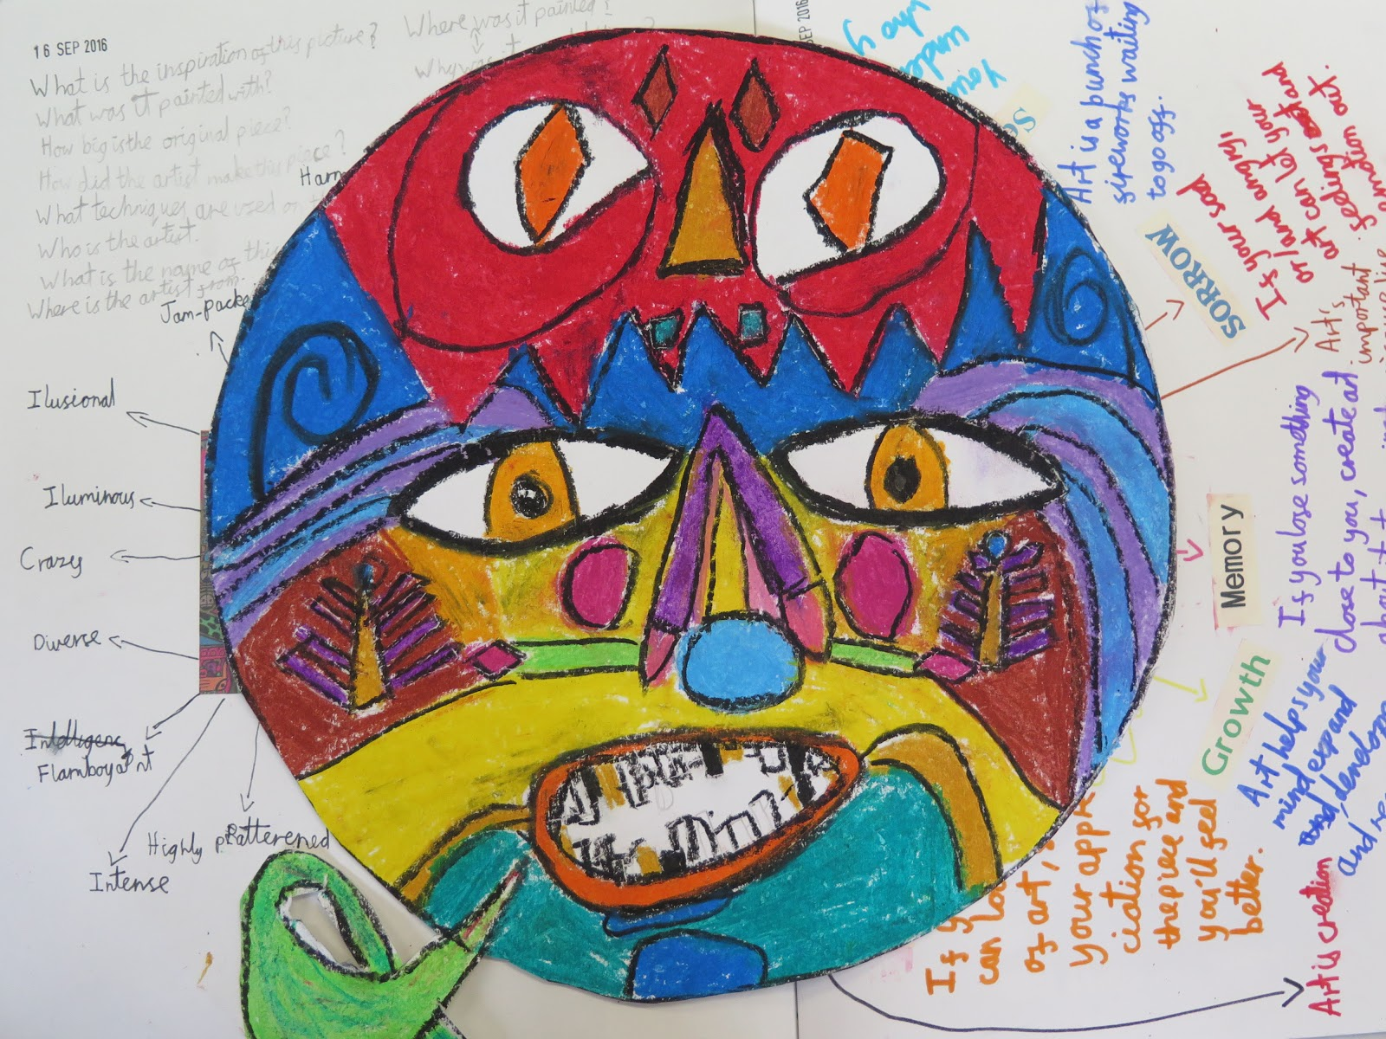  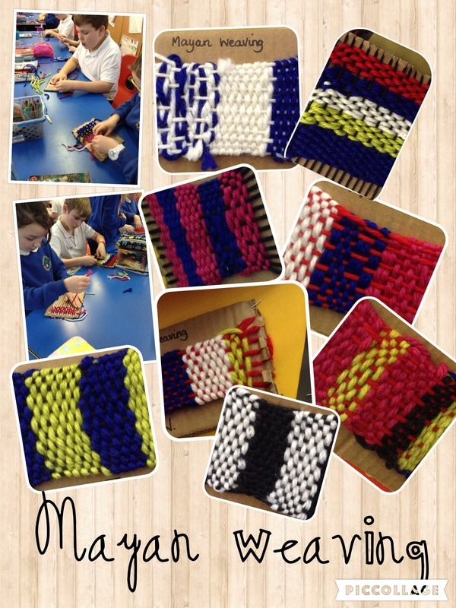 | Theme: Explorers  Skills:  Drawing: sketching ships – focus on 1 part  Proportion & scale  Painting: water colour landscape  Collage: Recreate landscape picture  Artist/ Craftsperson/ Designer: Artist who was on expedition | Theme: Natural Disasters  Skills:  Drawing: draw picture of before & after a disaster  Paintings: Natural disaster painting in the style of Peters  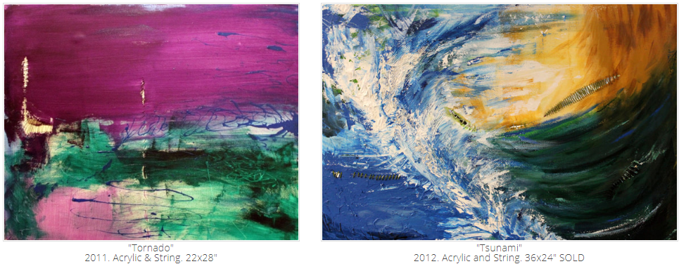  Sculpture: Building after natural disaster  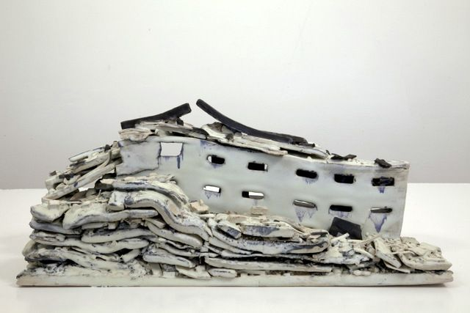  Artist/ Craftsperson/ Designer: Stephanie Peters (painter)  Alison Ruttan's "Natural Disaster" (Sculptor) | Theme: Global Issues  Skills:  Drawing – Sketch of sculpture 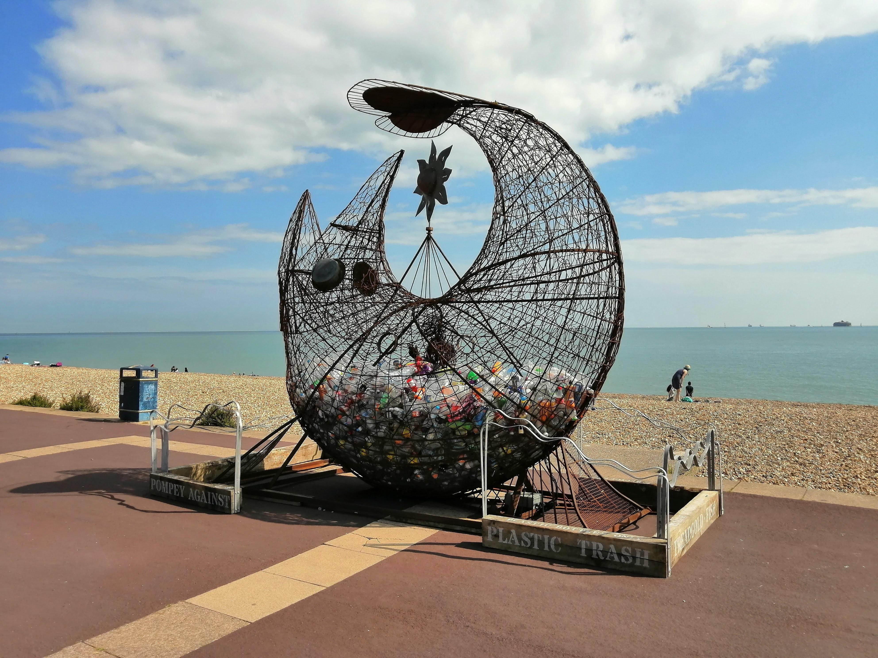  Painting – Under the sea scene incorporating plastic  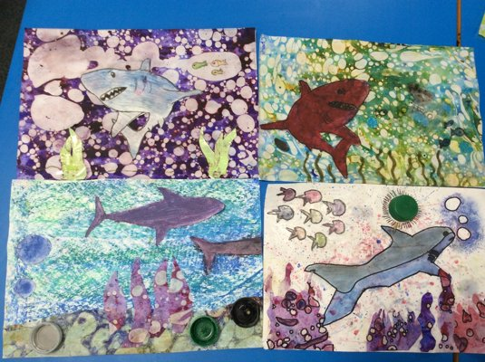  Sculpture – Design and make a sculpture in the style of Codling  Artist/ Craftsperson/ Designer: Pete Codling | Theme: London  Skills:  Drawing: Ken Done line drawing of Tower Bridge  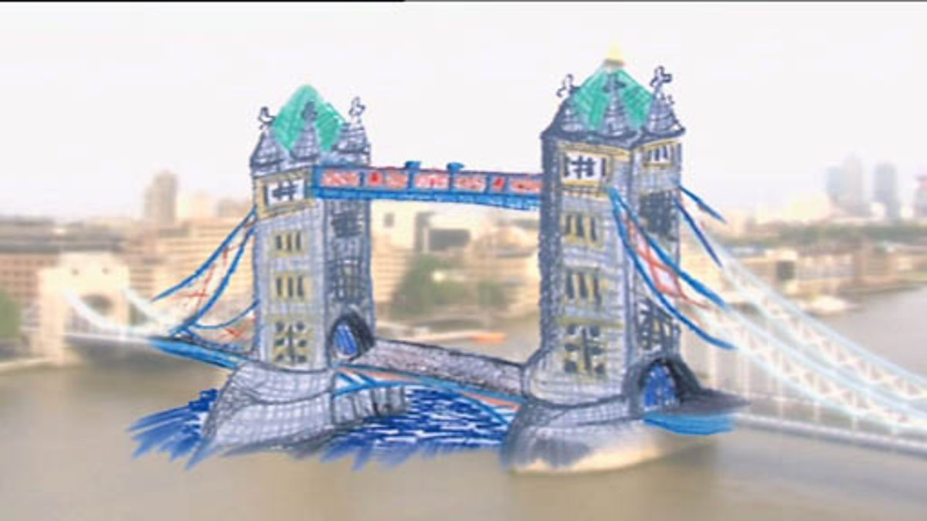  Painting: London Landmarks  Printing: Create a print of London in the style of Brodholt  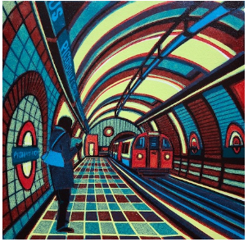 | Theme: Lights, Camera, Action  Skills:  Drawing: Create a comic strip in the style of Disney  Painting: Design own character  Art & ICT: Poster for show  Artist/ Craftsperson/ Designer: Walt Disney?  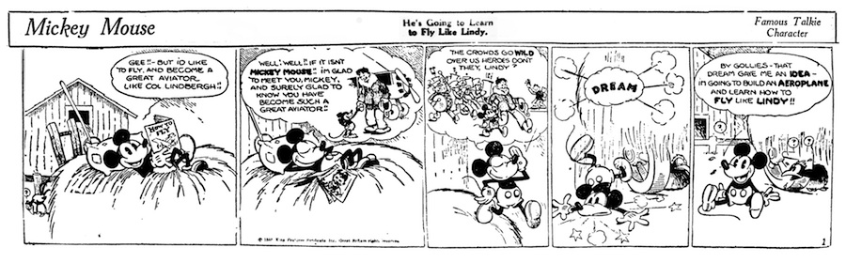

Skills
Drawing | Painting | Collage | Printing | Textiles | Sculpture | Art & ICT

Each art Journey should ideally involve drawing & painting but then move onto another skill.
e.g. Drawing – self portrait using pencil
Painting – Self portrait Picasso style
Sculpture – Abstract faces using wire & pipe cleaners
Artist – Picasso

