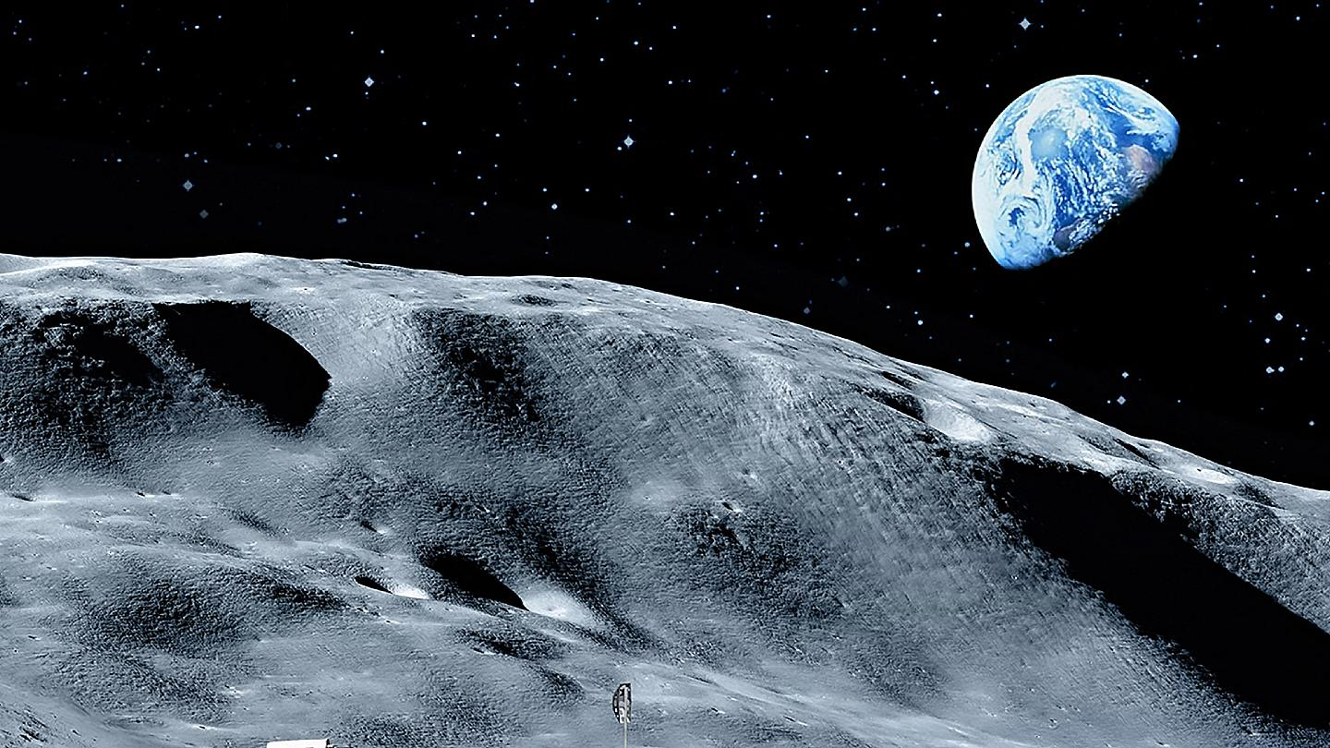

**ICT**

* **Begin to use internet services to share and transfer data to a third party**
* **Use filters in search technologies effectively**
* **Use filters in search technologies effectively and appreciate how results are selected and ranked**

**PSHE/P4C/School Value**

* **Focus**
* **Current affairs**

**MFL - Spanish**

* **To be able to understand that there are people and places in the world around me that are different to where I live and play.**
* **To be able to understand that some people speak a different language to my own.**
* **To be able to say and repeat a few short words or phrases.**
* **To write and copy simple phrases. To be able to understand a few familiar spoken words and phrases.**

**RE – Stewardship**

* **Begin to describe/explain what stewardship is**
* **Begin to describe/explain how stewardship is expressed within the Muslim world view**
* **Begin to evaluate by describing/explaining the importance and relevance of stewardship to Muslims and to themselves**
* **Begin to describe/express a personal response to the concept of stewardship**
* **Begin to describe/explain how the concept can be applied in their own and others’ lives**

**PE – Tennis/Jazz Dance**

* **Practise actions and patterns from style, improvise own moves typical of the style, create short motif that fits to music, create partner and group dance.**
* **Develop the techniques for ground strokes and volleys, learn backhand technique and use it in a game**
* **Know and use the scoring system and court for singles tennis, use doubles scoring in a doubles tennis game.**

**Music**

* **Singing skills and composing using environment sounds through percussion**

**Geography – The Earth**

* **Know the location of: capital cities of countries in the British Isles and UK, seas around the UK, European Union countries with high populations and large areas and the largest cities in each continent**
* **Recognise the shapes of different countries and continents**
* **Recognise the different shapes of countries**
* **identify the physical characteristics and key topographical features of countries**
* **Use maps, atlases, globes and digital/computer mapping to locate countries and describe features studied**

**Science – Space**

* **describe the movement of the Earth, and other planets, relative to the Sun in the solar system**
* **describe the movement of the Moon relative to the Earth**
* **describe the Sun, Earth and Moon as approximately spherical bodies**
* **use the idea of the Earth’s rotation to explain day and night and the apparent movement of the sun across the sky**
* **describe the Sun, Earth and Moon as approximately spherical bodies**

**Art**

* **Drawing – Texture space pictures using pastels**
* **Painting – Peter Thorpe inspired rocket painting**
* **ICT – Create a space background for rocket**

**Space and the Earth**

**Spring 1– Year 5**

